User Guide for Customizing Scatterplots

1. Introduction
The points in scatterplots are drawn with two dimensions as coordinates. In the diagonal plots, the same dimension is used as the two dimensions, so a straight line is drawn, and it makes little sense for data visualization. We replaced the diagonal scatter plots with other meaningful plots to make full use of the diagonal space.

The histogram, one dimension (temporal graph) and two dimension are selected as the options for diagonal plots. For two dimension, there are two ways to decide the location of point: the first way is that the coordinates are derived from the order and the column size in the data file, which create a rater layout, the second way is that the coordinates can be selected to be any two dimensions. In both cases, the color of the points is set proportional to the value for the corresponding dimension.

The common operation for scatterplots:
- How to show the scatterplots?
Select “View-> Display Mode -> ScatterPlot Matrices”, the scatterplots will be shown in the main window.
- How to open the dialogue that controls the options for scatterplots and diagonal scatterplots?
Select “Tools-> Scatterplot Option”, and the Scatterplot Option Dialogue will be shown.
- How to change the point shape or point size?
In the Scatterplot Option Dialogue, you can change “Point Shape” or “Point Size” directly.

If you are not familiar with the operation of XmdvTool, you can read the on-line help. For other documents, please visit the XmdvTool homepage: http://davis.wpi.edu/~xmdv/ .

The Scatterplot Option Dialogue:
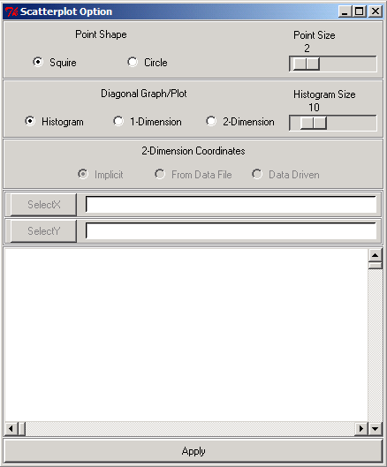

An example of scattplot whose point shape is circle and whose point size is 12:
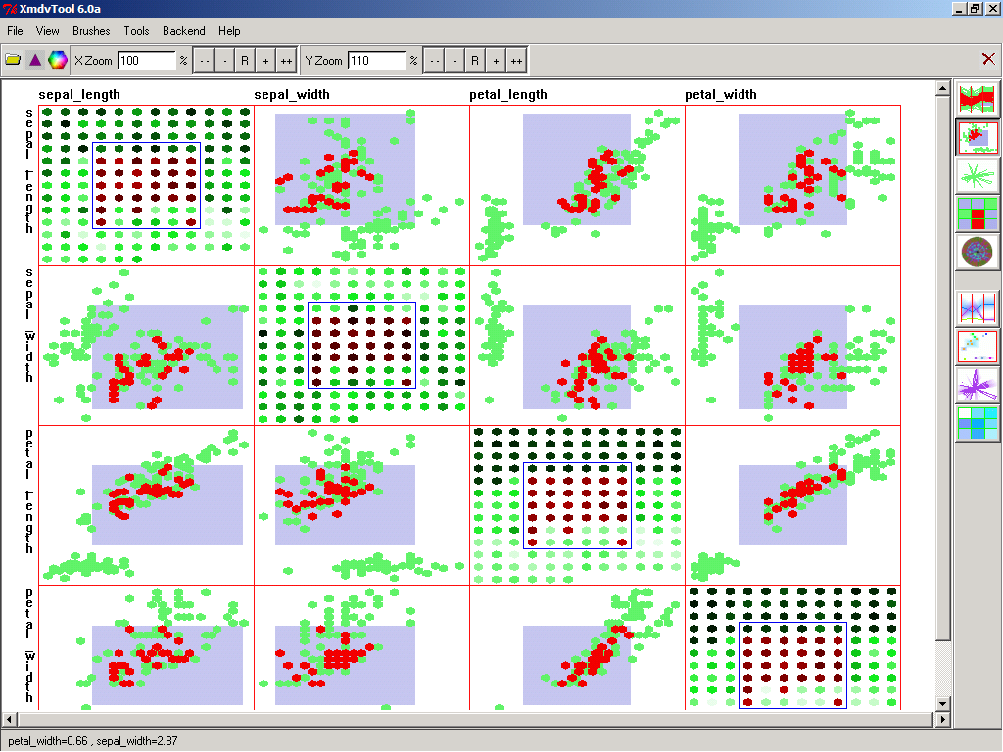

2. Histogram
Histogram shows the data distribution by ranges of data. On every diagonal plot, one dimension is used to generate the plot. From its minimum value to its maximum value, the data are proportionally partitioned into several sub-ranges. The number of sub-ranges is decided by the histogram size. The height of the histogram bar is decided by the number of data points whose value for that dimension is in the range of that bar.

Operations:
First navigate to the scatter plot, and then open the Scatterplot Selection dialogue, and the default diagonal plot should be histogram. In the dialogue, the Histogram Size can be changed, to adjust the number of bars in the histogram.

Meaning:
The green outline shows the histogram for the entire data corresponding to that dimension. The brushed bar (usually red) shows the histogram of the brushed data in the scatterplots.

Brushing:
The brush in the histogram is based on the corresponding dimension. By resizing or moving the brush, the range of that dimension value is changed, and the range of the dimension will be used as brush, just as the range of data is used as brush in the normal scatter plot.

Example:
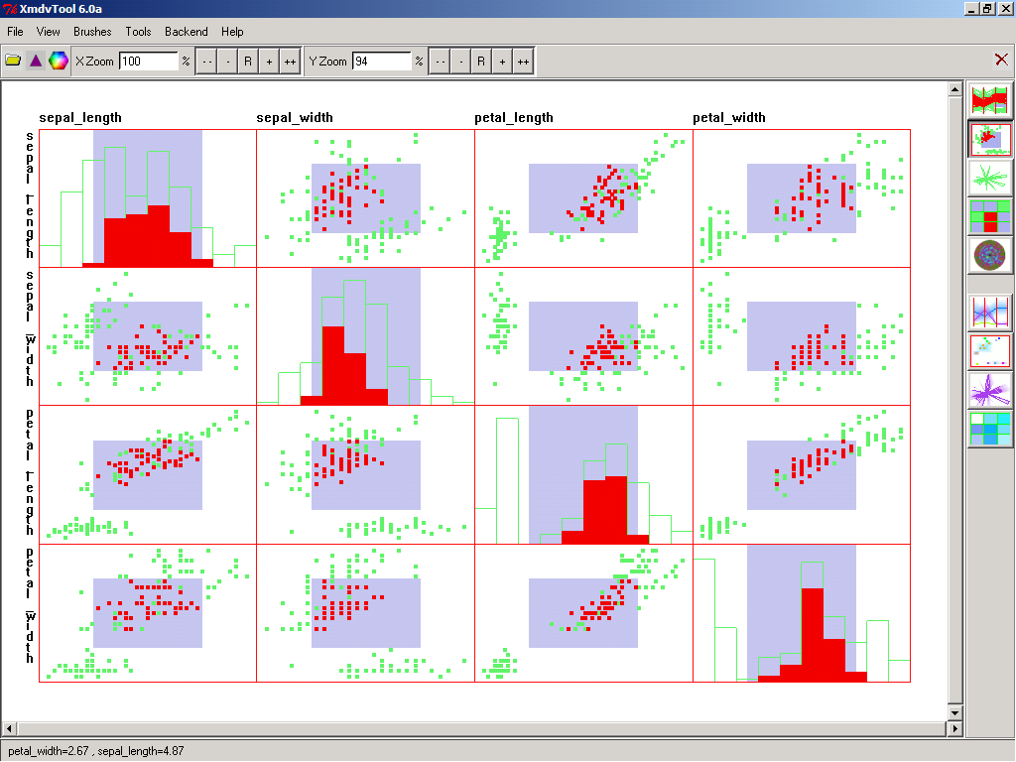

3. One Dimension (Temporal Graph)
Temporal Plot shows the data as a function of data order. The order can be time, space, sequence number or something else. The points are connected together to form lines.

Operations:
In the dialogue, select 1-Dimension, then the Temporal Graph will be shown.

Meaning:
The green lines indicate the non-brushed data and the red lines indicate brushed data.

Brushing:
The brush of the temporal graph is based on the order of the data and the dimension value. The range of the order becomes the additional condition of brush. By resizing and moving the brush, the range of the order and/or the range of the data value are changed, and they are used as conditions together. Multi-selection operations are also supported by painting over the data while holding down the shift key. This uses the same rules as the normal dimension multi-selection.

Example:
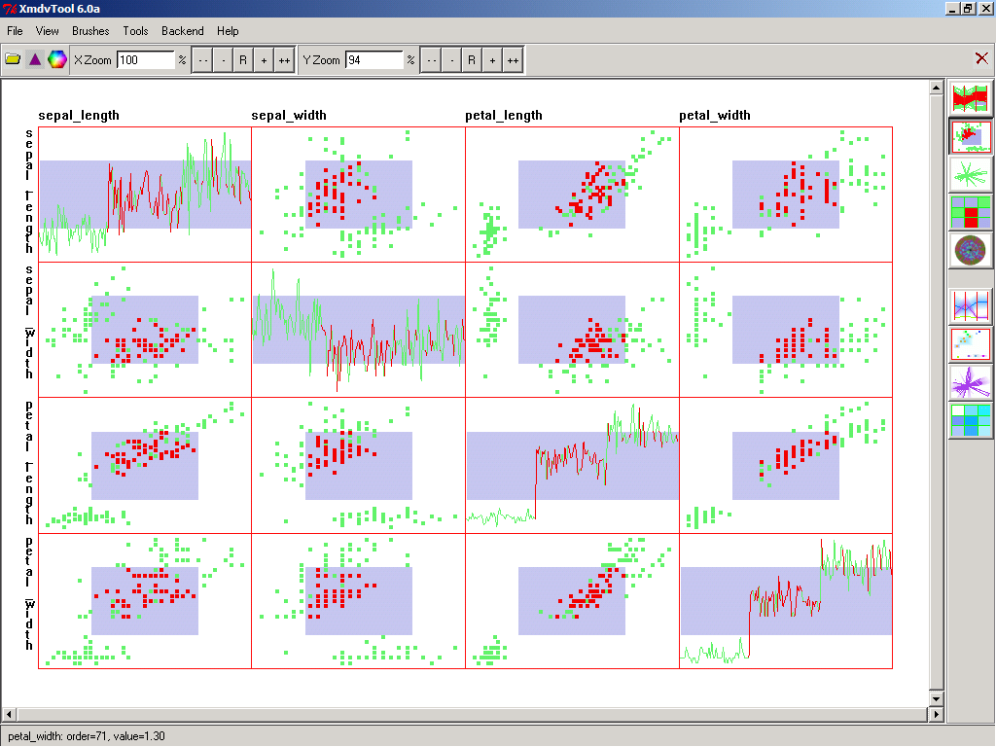

4. Two Dimension Plots
Two Dimension Plots include raster plots and data driven plots.

The coordinates of the raster plot are derived from the order of the data and the column size or width. The x coordinate is the remainder of dividing the order with the column size; the y coordinate is the quotient of dividing the order with the column size. If the data are collected exactly in a regular grid, then this method is reasonable. The coordinates of the data driven plot are selected from any two dimensions.

4.1 Raster Plot
Operations:
Select “2-Dimension”, then “2-Dimension Coordinates” will be enabled. “Implicit” means using the default column size which is defined as the square root of the number of data points, and “From data File” means using the column size set in the data file. If the data file sets the column size, the “From Data File” will be enabled. Select “Implicit” or “From data file”, click the “Apply”, and the raster plot will be shown in the main window.

The column size or width is set in the first line of the data file. The first line includes three parameters, the number of dimensions, the number of data points and column size. They are separated by blank, and end with new line. To be compatible with the old version of data file, it will use a default column size if the column size is not set in the data file. As an example, the astronomy.okc data file sets the column size with 24.

The data values are displayed by a color scale. For the unbrushed data, the base color is green, and for the brushed data, the base color is red. The lightness of the color is proportional to the dimension value. The point size can be changed to make the color easy to recognize. A rectangle will mark the region of the brushed data.

Brushing:
The brush on raster plot is based on the two raster dimensions, the remainder and the quotient of dividing the data set size with the column size or width. We can treat the whole plot as a region, and then the brushed part is a small region. This small region is used as additional condition for brushing data. It can be resized and moved. This brush also supports multi-selection. After multi-selecting points, the tool will automatically set the brush to the minimum region, which can accommodate all the selected data.

Example:
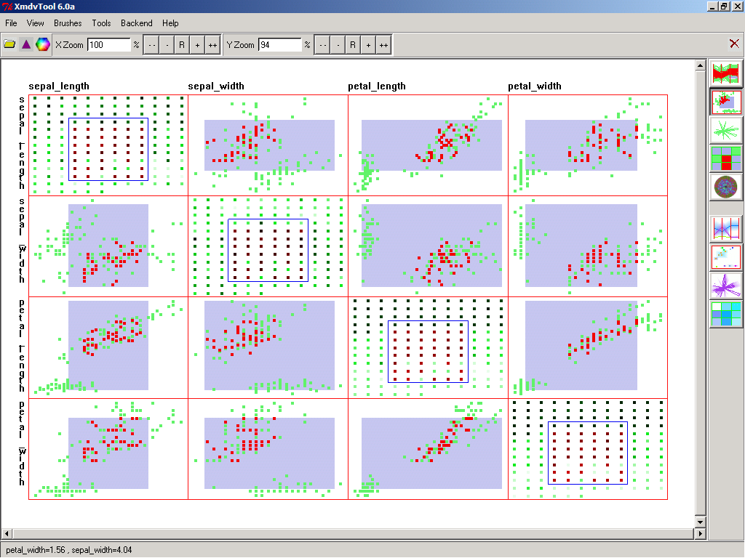

4.2 Data Driven Plot
Select the “2-Dimension”, then “2-Dimension Coordinates” will be enabled. Select “Data Driven”, then a list of dimensions will be displayed; Select one dimension and click “SelectX”, then the dimension will be displayed in the right entry; Select another dimension and click “SelectY”, then the dimension will be displayed in the right entry; Click the “Apply”, the data driven plot will be shown in the main window.

As in the raster plot, the data values are displayed using a color scale.

Brushing:
The brush on the raster plot is based on the two raster dimensions, which decide the location of point. Since these two dimensions are also used as normal data dimensions, the brushing operations of resizing, moving and multi-selecting are the same as the non-diagonal brushing operations.

Example:
